# Multiple Arguments - Python Exercise

Below is the image provided along with the recreated question, terminal output, and answer:

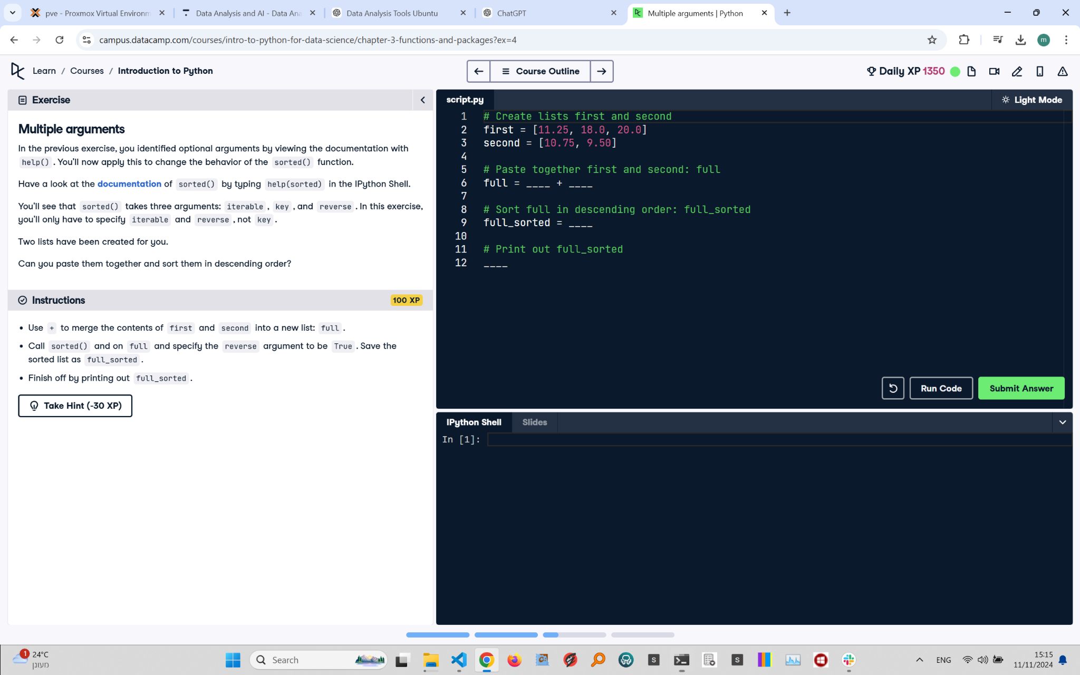

## Recreated Question and Terminal

Multiple Arguments  
In the previous exercise, you identified optional arguments by viewing the documentation with help(). You'll now apply this to change the behavior of the sorted() function.

Have a look at the documentation of sorted() by typing help(sorted) in the IPython Shell.  
  
You'll see that sorted() takes three arguments: iterable, key, and reverse. In this exercise, you'll only have to specify iterable and reverse, not key.  
  
Two lists have been created for you.  
  
Can you paste them together and sort them in descending order?

Instructions:  
- Use + to merge the contents of first and second into a new list: full.  
- Call sorted() on full and specify the reverse argument to be True. Save the sorted list as full_sorted.  
- Finish off by printing out full_sorted.

## Answer

# Create lists first and second  
first = [11.25, 18.0, 20.0]  
second = [10.75, 9.50]  
  
# Paste together first and second: full  
full = first + second  
  
# Sort full in descending order: full_sorted  
full_sorted = sorted(full, reverse=True)  
  
# Print out full_sorted  
print(full_sorted)

## Explanation of the Answer

The code merges the lists first and second using the + operator. The sorted() function is called on the combined list full, with the reverse argument set to True to sort in descending order. The result is stored in full_sorted and printed, displaying the numbers from largest to smallest.